Wan Yuan American High School's First Student Council Elections Were a Huge Success
SUIS Wan Yuan campus in Shanghai, China had its very first student council elections this year. The event was a great way for the students to experience new things and come together as a school.
October 10th at the Wan Yuan American High School in Shanghai, China there was a student council election. Almost all the students participated by either running for office or helping support those who were running. Students and teachers alike were surprised by the progress and final results of the election.
At the beginning of the election there were candidates from both the Blue and Red houses. In the Wan Yuan High School the students are split into two groups which are called houses. The houses compete against each in many types of competitions such as dodge ball, talent shows, and presentations. They had to give speeches and participate in a debate. Garith, Kathy, Linda, and Sherry were candidates who had proven themselves as good leaders in previous school school activities, which made it hard for the students and teachers to predict who would win. “I think there are a lot of good candidates and a lot of them have a good chance to win. I don't know who has the most chance though.” Said math teacher Mr. Andy.
During the election the candidates had to make speeches about what they were going to do if they were elected president and had to participate in a debate held by the principle, Mr Eaton. During the debate they would be asked questions about their thoughts on school problems. One big shock was when Josh, one of the 2 Americans running for president, decided to drop out which he announced during his speech. Mr. Eaton later said was just about to give him his endorsement. Everyone was astonished; who had a chance to win. The rest of the speeches were surprise-free; some of them went on for a very long time while others were extremely short. Some of the longer speeches were not as well delivered and were hard to understand. Linda's speech was lengthy, however the audience was able to understand her well. “Linda's speech flowed very well.” Said classmate Angela.
Presidential debates were next on the election agenda. The candidates sat on a stage, first Red house then Blue house, and were asked questions by their principal, Mr. Eaton. Josh Mata, student at Wan Yuan said “The debates went very well, although candidates like Linda and Kathy were much more prepared than candidates like William and Valentino.” Some answers went on a very long time before reaching the point like Linda and Sherry others like Alyssa's and Kathy's were very short. Overall, the debates were a time to view the candidates feelings on many issues throughout the school.
The next week it was time for the caucuses. “I am really nervous. This is going to be so embarrassing. We have to stand infront of everyone while they stand behind us.” Blue House candidate Kathy said. “Having to stand in a room filled with people waiting to see who will stand behind you is very scary.” Blue House candidates Valentino, Sam, and Alyssa were eliminated and didn't have very many votes. Students then had to vote for either Kathy or Flavia. In Red House Garith and Sherry were eliminated and people had to then make a choice between William and Linda. In the end Blue house chose Kathy and Red house chose Linda. Both of them were very excited, but Mr. Eaton said “ I am really not sure who is going to win. It's going to be a tight race.” Below Right: Presidential candidates Kathy(Left), Linda(Middle), and Alyssa(Left)


For the final election they chose to hold a normal election. Teachers set up a room in the Library and set up the computers so students could enter who we were voting for. Students did this by entering a locked screen with everyone's names on it and clicking on who they would like to vote for in each category. They could vote for Kathy or Linda or either of the 10th grade representatives and either of the 9th grade representatives. The 10th grade representatives were Jeff and Jayden. In the end Jayden won. The 9th grade representatives were Mario and Susan. In the end Mario won. The last winner to be called was the person who won the presidential election. They would be named Wan Yuan's first Student Council President, Kathy of the Blue House, won the presidency. The room exploded with cheers from her fellow house mates. She had already announced that Flavia would be appointed vice president, Alyssa Walker would be appointed secretary, and Kyd would be appointed historian. The appointed students gave hugs and thanks to their new president Kathy. They were all extremely honored and were very excited to be the first cabinet of Wan Yuan. The new vice president, Flavia, told everyone “I am excited because I get to be the very first in history.” Below right: Presidential candidates Alyssa(Left) and Kathy(Right)
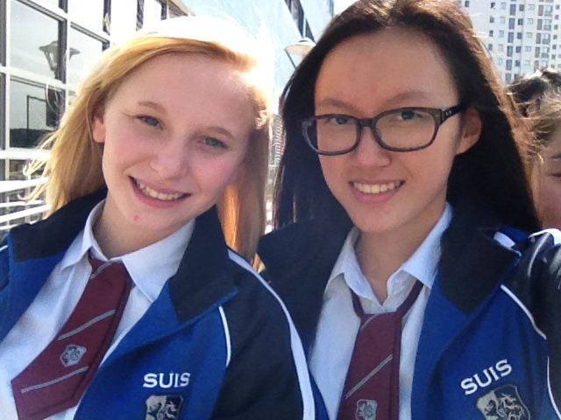
In the end everyone had a new experience to say they were a part of. Everyone took their losses with pride and wins with modesty. With Kathy as president, Flavia as vice president, Alyssa as secretary, Kyd as historian, Mario as 9th grade representative, and Jayden as 10th grade representative Wan Yuan was ready to start a new chapter of it's first year.

